**Software Architecture**

The Discworld AnkhMorpork is board game whose basic data structure was designed in the build1. This build demonstrates actual game play as a web application. The figure 1 given below gives a very high level design architecture of the game.

The application starts with the client requesting for a web page from the web server which in our case is Apache Tomcat. The server reads the requested JSP pages and executes it using JSP container and process the result to the web client. The source of data here is a JSON file which is accessed using JQuery.

HTTP Request

Web Server

(JSP Container)

Java Server Pages

Web Client

Apache Tomcat

HTTP Reply

Data Source

(JSON File)

Figure 1. A High Level View

The figure 2 given below displays the class diagrams and relationship among them. Here six different classes used are taken into consideration are: AnkhMorPorkLauncher class which has the actual logic of game launching.

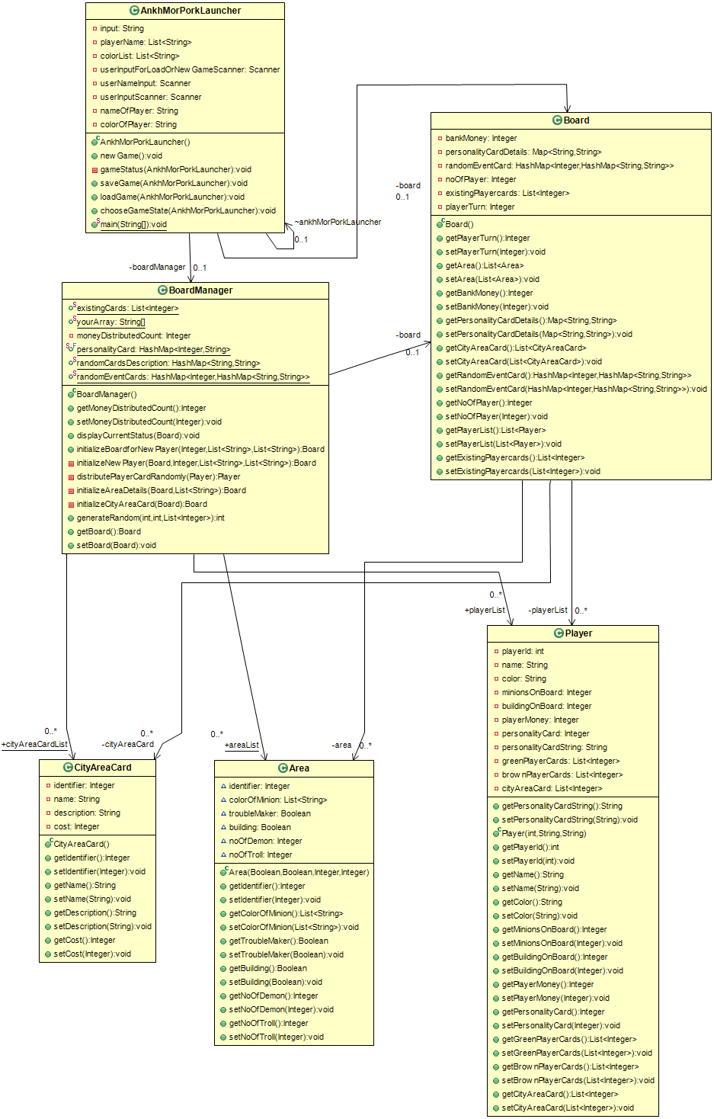

Figure 2. UML Class Diagrams and their Relationship

Board, Board Manager classes have details of current status of the game board including player turn, random event, number of players and many more as given in class diagrams.

CityAreaCard class possesses information regarding a city area including its cost, name, description and identity.

The Area class contains status of a city area i.e. number of demons, troll and presence of trouble marker, building and color of minions in that area.

The Player class manages the details of individual players involving minions on board, building on board, player money, personality of player, city area cards, player cards etc.